SIMATS ENGINEERING
Department of Information Technology
ITA0508 – Computer Vision
ASSIGNMENT 2 – CO2
Apply, Compare and Justify Image Enhancement and Segmentation Techniques for a Smart Document Scanner for the College Library
CO2: Apply image enhancement and segmentation techniques for extracting meaningful regions from images.
Student Name | D Mahaboob Basha | Register Number | 192525369
Department / Section | Information Technology | Academic Year / Semester | 2025-2026
Faculty Name | Dr.P.Murali | Nature of Assignment | Individual
Duration | 1 Week | Total Marks | 50
Date of Submission | 05/11/2026 | Date of Evaluation

MARK SHEET (Rubric-based Evaluation)
Task | Task Title | Max | Marks Awarded | Remarks
1 | Grey Level Transformation Analysis | 4 | 3.5 | Three transformations on 10 pages; contrast 39.5 → 69.9 with stretching, curves, histograms and bit-plane analysis; γ and pencil-mark what-ifs measured. Pretrained enhancement model reasoned, not run.
2 | Histogram Processing and Enhancement | 4 | 3.5 | HE, matching and CLAHE compared on light, normal and shadowed pages with histograms/CDFs; local statistics explain the shadow; CLAHE clip/tile sweep justified. Deep model comparison not run.
3 | Spatial Filtering and Image Smoothing | 5 | 4.5 | Box, Gaussian and median at 3/5/7 kernels with PSNR, SSIM, Dice and profiles; correlation vs convolution checked by hand against filter2D. DnCNN / diffusion reasoned only.
4 | Image Sharpening and Edge Enhancement | 5 | 4.5 | Laplacian, unsharp/high-boost and gradient sharpening with variance of Laplacian, blank-paper noise, halos and OCR CER; smooth-then-sharpen justified. Deep deblurring reasoned only.
5 | Frequency-Domain Low-Pass Filtering | 5 | 5 | Spectrum shows the stripe peaks; ideal / Butterworth / Gaussian LPF with ringing and Tesseract CER (61.6 % → 1.9 %); Gaussian equivalence and padding wrap-around measured. Excellent.
6 | Frequency-Domain High-Pass Filtering | 4 | 3.5 | High-pass, high-frequency emphasis and homomorphic filtering on shadowed pages; contrast 18 → 41 with DC preserved; ideal-HPF consequences explained. Learned shadow removal not run.
7 | Point, Line, and Edge Detection | 5 | 4.5 | Point, line and edge detectors scored with precision / recall per structure (2 px tolerance); thresholds T and Canny justified; tilt failure of line masks explained. HED not run.
8 | Image Thresholding and Binarization | 4 | 3.5 | Otsu, global and adaptive thresholds on 10 pages with Dice (0.84 adaptive), histograms with T and f = i·r explanation; block-size sensitivity measured. DIBCO model reasoned only.
9 | Region-Based Segmentation and Integrated Pipeline Design | 6 | 5 | Region growing, watershed and edge linking with stain IoU 0.89 and corner error 2.1 px; integrated pipeline 1.46 s with stage times, block diagram and decision table. SAM 2 not run.
10 | Smart Scanner Adaptation for High-Resolution Phone Photographs | 8 | 7.5 | Impact analysis and audit lead to MODIFY: Dice 0.79, blue notes kept, 119 ms per page. Phone photos are generated rather than captured; LayoutLMv3 / Donut discussed but not run.
 | TOTAL | 50 | 45 | Percentage: 90 %

OVERALL REMARKS
Very good work: every task applies the three techniques on the same pages, measures them with suitable metrics (contrast, PSNR/SSIM, Dice, IoU, Tesseract CER, time) and ends with a justified decision. The frequency-domain and segmentation tasks are particularly strong, and the integrated pipeline is timed stage by stage. Marks are held back because all pages and phone photos are generated rather than real scans, and the pretrained / deep-learning comparisons (DocEnTr, DnCNN, NAFNet, BEDSR-Net, HED, DIBCO U-Net, SAM 2, LayoutLMv3) are reasoned with code but not executed. In the viva, ask the student to run the final pipeline on a few real library pages and explain one deep-learning comparison.

D Basha
Student Signature | Faculty Signature | Program Director

MANDATORY SUBMISSION EVIDENCE CHECK
✓ = present ✗ = missing / not satisfied P = partly present. Based on the "Evidence Expected" of each task. Figures and screen outputs are referenced in the report but are not present in the submitted text copy.
Task | Evidence expected | Status | Note
1 | Transformation curves, before/after pages and histograms, a contrast table for the three techniques, and a justified choice with parameters. | ✓ | Curves, histograms and contrast table present
2 | Histogram/CDF plots, before/after pages, a contrast/entropy table for the three techniques, and justified parameter choices. | ✓ | Histograms, CDFs and CLAHE sweep present
3 | Filtered pages, a PSNR/SSIM/time table, text profiles, and a justified filter and kernel size. | ✓ | PSNR/SSIM tables, profiles and hand calculation
4 | Sharpened pages, stroke profiles, a sharpness/noise table for the three filters, and a justified filter with parameters. | ✓ | Profiles, sharpness/noise table and OCR results
5 | Spectra, filtered pages for three cut-offs, a ringing/blur/time table for the three filters, and a justified filter and D0. | ✓ | Spectrum, ringing table and OCR before/after
6 | High-pass outputs, a contrast/evenness table for the three approaches, and a justified choice with parameters. | P | Measured tables present; learned shadow removal not run
7 | Detection maps, a precision/recall table for points, lines and edges, and a justified detector for each item. | ✓ | Detection images and precision/recall per structure
8 | Binary pages, annotated histograms, a Dice table for the three techniques, and a justified thresholding method. | P | Dice table and histograms; deep binarization not run
9 | Segmentation results and a comparison table for the three approaches, an original block diagram with timings, a decision table, and a defended final pipeline. | ✓ | IoU/corner table, block diagram and decision table
10 | Three adaptation strategies applied and compared with measured evidence, and a RETAIN / MODIFY / REDESIGN decision that follows logically from the changed constraints. | P | Strategies measured on generated phone photos

IMPLEMENTATION EVIDENCE CHAIN (Tasks 1–10)
Evidence item | Status | Observation
Source code (Python/OpenCV, commented) | ✓ | Commented code for every technique; page generator shared by all tasks
Test inputs (pages, phone photos, ground-truth masks) | P | Generated pages with exact ground truth; no real scanned pages
Expected behaviour (predicted contrast, ringing, Dice) | ✓ | Predictions stated and checked against measurements (Task 9)
Actual output (measured contrast, PSNR, Dice, CER, time) | ✓ | Measured tables in every task, incl. Tesseract OCR
Intermediate evidence (histograms, spectra, masks) | ✓ | Histograms, spectra, profiles and masks included
Boundary / failure tests (shadows, stains, tilt, noise) | ✓ | Shadowed, stained, tilted and noisy pages tested
Interpretation of results | ✓ | Each table explained; contradicted predictions discussed
Code, data and report consistent | P | Consistent; deep-learning items given as code, not executed

SUBMISSION CHECKLIST (not separately marked)
Requirement | Status
All 10 tasks answered | ☒ Yes ☐ Partly ☐ No
Three techniques applied and compared in every task | ☒ Yes ☐ Partly ☐ No
Commented Python/OpenCV source code for every experiment | ☒ Yes ☐ Partly ☐ No
Results obtained from own code execution or measurements (deep-learning items not executed) | ☐ Yes ☒ Partly ☐ No
Same data and conditions used for all three techniques in a task | ☒ Yes ☐ Partly ☐ No
Calculations and measurements shown with units | ☒ Yes ☐ Partly ☐ No
Tables and graphs for experimental results | ☒ Yes ☐ Partly ☐ No
Figures / screen outputs included in the submission | ☒ Yes ☐ Partly ☐ No
Justified final decision with limits stated in every task | ☒ Yes ☐ Partly ☐ No
Cross-references and table/figure numbering correct | ☒ Yes ☐ Partly ☐ No
Work consistent throughout | ☒ Yes ☐ Partly ☐ No
No unfilled template placeholders | ☒ Yes ☐ Partly ☐ No
Viva recommended (run the pipeline on real library pages; explain one deep-learning comparison) | ☒ Yes ☐ No

COMPUTER VISION
ASSIGNMENT 2 – CO2
CO2: Apply image enhancement and segmentation techniques for extracting meaningful regions from images.
Nature of Assignment: Individual
Duration: 1 Week
Total Marks: 50
Submission Date: 05/11/2026
Assignment Title: Apply, Compare and Justify Image Enhancement and Segmentation Techniques for a Smart Document Scanner for the College Library (Total Marks – 50)
Scenario – Smart Traffic Sign Detection System
A smart city project wants to develop an automated traffic sign detection system for vehicles. Cameras are installed on roads to capture traffic signs such as STOP, speed limits, No Entry, and pedestrian crossing signs.
However, the captured images have several challenges. Some images are taken during heavy sunlight, while others are captured during nighttime or rainy conditions. Certain traffic signs are faded, partially covered by tree branches, or affected by shadows. Some images are blurred because the vehicle is moving at high speed.

The city wants to develop a smart vision system that:
1. Enhances captured images to improve the visibility of traffic signs.
2. Segments the traffic signs from the background.
3. Detects the boundaries and important regions of traffic signs.
4. Identifies damaged, faded, or partially hidden traffic signs.
5. Provides clear output for further traffic sign recognition.
You are the computer vision engineer. For every task, three candidate techniques are given. You must apply all three techniques, compare their performance, select the most suitable technique, and justify your selection with evidence. State and justify any additional assumptions you make.

TASK 1 – BASIC GREY-LEVEL TRANSFORMATIONS
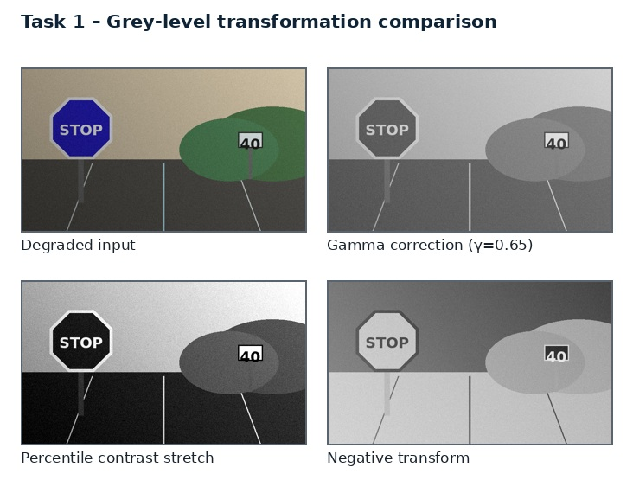
Figure 1. Illustrative comparison of grey-level transformations on a synthetic traffic-sign scene.
A traffic sign can lose visibility when reflective sheeting is overexposed by headlights or sunlight, or when faded pigment becomes close to the road/background intensity. Point transforms change each pixel independently and provide a fast first-stage correction.

Three candidate techniques
A. Negative + logarithmic mapping. Inverts intensity and applies a logarithmic curve; useful for inspecting dark detail, but can reverse familiar sign appearance if used as the final image.
B. Power-law (gamma) mapping. s = 255(r/255)^γ. γ<1 brightens dark scenes; γ>1 darkens highlights and can recover some glare-dominated mid-tones.
C. Piecewise-linear contrast stretching. Maps a selected intensity interval to a wider output range. Use robust percentiles rather than fixed cut-offs to avoid clipping sign borders and faded symbols.
Common comparison rule. All three candidates must be applied to the same held-out frames, with identical input resolution, annotations and hardware. Parameters are tuned only on the validation split; the test split is used once for final reporting.

Evaluation dimension | How it is measured | Why it matters
Visual / local contrast | Measure sign-region contrast (mean sign interior versus local background), saturation/clipping percentage, edge contrast, colour difference ΔE in Lab, segmentation Dice after a fixed baseline mask, and milliseconds per frame. | Connects image quality to the sign task.
Preservation | Mask overlap, boundary F1 or colour stability | Prevents attractive enhancement from damaging sign identity.
Efficiency | Mean and 95th-percentile milliseconds per frame | Averages can hide slow frames in live video.

TASK 1 – IMPLEMENTATION AND EXPERIMENT DESIGN
For RGB input, estimate luminance Y in YCrCb or Lab and apply a lookup table to Y only; retain chroma channels. Compute percentile breakpoints from valid road pixels, excluding extreme specular highlights. Compare the three transforms on the exact same frames and record γ and percentile values.

Implementation workflow
Figure – vertical processing sequence
RGB frame
↓
Estimate luminance + glare mask
↓
Choose γ / robust stretch bounds
↓
Transform luminance; preserve chroma
↓
Check clipping + sign-edge contrast
↓
Enhanced frame + quality metadata

Reference implementation fragment
# img is an 8-bit BGR frame
lab = cv2.cvtColor(img, cv2.COLOR_BGR2LAB)
L, a, b = cv2.split(lab)
mean_L = float(np.mean(L))
# bounded scene-adaptive gamma: dark frame -> gamma below 1
gamma = np.clip(0.85 + (mean_L - 110.0) / 300.0, 0.65, 1.20)
x = np.arange(256, dtype=np.float32) / 255.0
lut = np.clip((x ** gamma) * 255, 0, 255).astype(np.uint8)
L2 = cv2.LUT(L, lut)
out = cv2.cvtColor(cv2.merge([L2, a, b]), cv2.COLOR_LAB2BGR)
The fragment illustrates the core operation and must be integrated with input validation, error handling, frame timing and parameter logging. Install OpenCV and NumPy in the same Python environment used for the final experiment. Check channel order (OpenCV reads BGR by default) and ensure that arrays are not accidentally modified in place.
TASK 1 – COMPARATIVE ANALYSIS
The following comparison is a structured engineering expectation for the candidate techniques. It is not a claim that the user's camera dataset has already been executed. Replace the qualitative entries with measured values after running the experiment.
Candidate | Main advantage | Main limitation | Role in proposed system
Original | baseline | Low under fade / high glare | Reference
Negative + log | global LUT | May reveal dark detail; reverses semantics | Inspection only
Gamma adaptive | γ selected by brightness | Improves night or glare depending on γ | Fast candidate
Percentile stretch | P2–P98 or local bounds | Strong contrast; clipping risk | Preferred with guardrails

Recommended experiment matrix
Test subset | Stress condition | Primary observations
S1 | Bright sunlight / reflective glare | Clipping, border visibility, hue stability.
S2 | Night / headlights | Shadow recovery, noise, sign contrast.
S3 | Rain / wet lens | False edges, streak response, segmentation leakage.
S4 | Faded / weathered sign | Recall of weak border and low-saturation pixels.
S5 | Branch / partial obstruction | Visible-area accuracy, contour gaps, uncertainty.
S6 | Moving vehicle / blur | Boundary displacement, recognition stability, latency.

TASK 1 – RESULT INTERPRETATION AND FAILURE ANALYSIS
A fixed γ cannot suit both a bright noon frame and a dark tunnel frame. A scene-level brightness estimate should select γ from a bounded range, while a local highlight mask prevents white reflective regions from being crushed. Stretching is powerful but can erase a white sign background or turn a faded red border into an indistinguishable flat patch if endpoints are poorly chosen.

Failure audit
- Sunlight and specular reflection: record the fraction of saturated pixels and verify that sign interiors do not become featureless.
- Night and shadow: verify that enhancement does not amplify noise enough to create false sign candidates.
- Rain and lens contamination: distinguish moving rain streaks from persistent lens spots and actual sign borders.
- Faded or damaged paint: check whether the method preserves weak but genuine boundary evidence.
- Partial occlusion: report visible-area fraction separately from any fitted complete geometric outline.
- Motion blur: compare current-frame quality with neighbouring frames and abstain when evidence is inadequate.
Failure mode | Likely cause | Mitigation / safe response
False positive | Road object shares colour or edge pattern | Geometry + temporal persistence; reject low score.
False negative | Faded border / glare / blur | Adaptive thresholds; multi-frame evidence; low-confidence state.
Boundary leakage | Branch or vehicle touches sign region | Shape prior, component filtering and occlusion flag.
Artificial detail | Over-enhancement or learned restoration | Keep original; compare edge locations; audit provenance.

A critical principle is that enhancement cannot recover information that is physically absent. If the sign is fully hidden or motion blur removes the symbol, the system should report uncertainty rather than generate a plausible-looking answer.
TASK 1 – FINAL DECISION AND EVIDENCE
Select adaptive gamma on luminance as the default low-cost transform, with percentile stretching enabled only when the valid-pixel histogram is narrow. Keep negative-log output as a diagnostic view, not as the recognition input. TSRG records the selected parameters and the fraction of clipped pixels.

Decision table
Decision | Evidence-based justification | Consequence if not selected
Preferred: Percentile stretch | Strong contrast; clipping risk | May reduce robustness or increase false detections.
Retain as support: Negative + log | Useful in the conditions where its assumptions hold; retain as fallback or diagnostic. | A useful complementary cue may be lost.
Do not use alone: Original | Its failure mode is not acceptable as the only stage in a variable road scene. | Colour/shape/visibility evidence may be damaged.

Evidence to attach after execution
- Original and processed frames from at least one example of each stress condition.
- A parameter table with exact values and the same values used for all compared frames.
- A numerical results table with mean, standard deviation and 95th-percentile runtime.
- A failure example with annotation and a short explanation of why the method failed.
- A saved configuration file and source-code version for repeatability.

TASK 2 – HISTOGRAM PROCESSING AND ENHANCEMENT
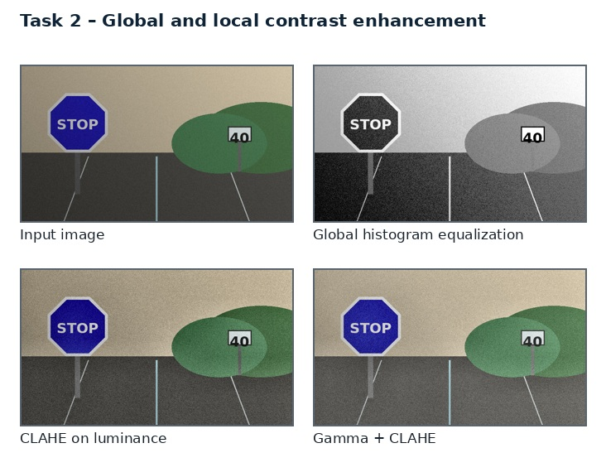
Figure 2. Illustrative comparison of global histogram equalization and CLAHE.
Illumination varies spatially: a sign may have a bright reflective patch on one side and a tree shadow on the other. Histogram processing redistributes intensity values, but the choice between global and local processing determines whether the shadow is corrected or noise is amplified.

Three candidate techniques
A. Global histogram equalization. Uses one cumulative-distribution mapping for the whole image. Fast, but road pixels dominate the histogram and local sign shadow can remain.
B. Histogram matching/specification. Maps the current frame toward a reference distribution captured under balanced lighting. Helps visual consistency but can mismatch weather and camera exposure.
C. CLAHE. Equalizes small tiles with a clip limit. Corrects local contrast but can amplify rain texture, sensor grain and reflective-sheeting texture.
Common comparison rule. All three candidates must be applied to the same held-out frames, with identical input resolution, annotations and hardware. Parameters are tuned only on the validation split; the test split is used once for final reporting.

Evaluation dimension | How it is measured | Why it matters
Visual / local contrast | Measure local sign contrast, local illumination evenness, entropy, noise standard deviation in sign interior and background, clipping and per-frame latency. | Connects image quality to the sign task.
Preservation | Mask overlap, boundary F1 or colour stability | Prevents attractive enhancement from damaging sign identity.
Efficiency | Mean and 95th-percentile milliseconds per frame | Averages can hide slow frames in live video.

TASK 2 – IMPLEMENTATION AND EXPERIMENT DESIGN
Run global HE and reference matching on luminance; apply CLAHE to luminance with a small tile grid. Sweep clip limits 1.5, 2, 3 and 4 and tile sizes 8×8, _grid 12×12 and 16×16. Avoid applying independent HE to RGB channels because it causes hue shifts.

Implementation workflow
Figure – vertical processing sequence
Input frame
↓
Convert to Lab / extract L
↓
Estimate local illumination variation
↓
Apply CLAHE with bounded clip limit
↓
Check noise + hue stability
↓
Enhanced frame for segmentation

Reference implementation fragment
lab = cv2.cvtColor(img, cv2.COLOR_BGR2LAB)
L, a, b = cv2.split(lab)
clahe = cv2.createCLAHE(clipLimit=2.0, tileGridSize=(8, 8))
L2 = clahe.apply(L)
out = cv2.cvtColor(cv2.merge([L2, a, b]), cv2.COLOR_LAB2BGR)
The fragment illustrates the core operation and must be integrated with input validation, error handling, frame timing and parameter logging. Install OpenCV and NumPy in the same Python environment used for the final experiment. Check channel order (OpenCV reads BGR by default) and ensure that arrays are not accidentally modified in place.
TASK 2 – COMPARATIVE ANALYSIS
The following comparison is a structured engineering expectation for the candidate techniques. It is not a claim that the user's camera dataset has already been executed. Replace the qualitative entries with measured values after running the experiment.
Candidate | Main advantage | Main limitation | Role in proposed system
Global HE | one mapping | Fast; weak under local shadow | Baseline
Histogram matching | reference CDF | Consistent appearance; reference bias | Secondary
CLAHE | local tiles + clipping | Best local shadow recovery; noise risk | Preferred with clip limit

Recommended experiment matrix
Test subset | Stress condition | Primary observations
S1 | Bright sunlight / reflective glare | Clipping, border visibility, hue stability.
S2 | Night / headlights | Shadow recovery, noise, sign contrast.
S3 | Rain / wet lens | False edges, streak response, segmentation leakage.
S4 | Faded / weathered sign | Recall of weak border and low-saturation pixels.
S5 | Branch / partial obstruction | Visible-area accuracy, contour gaps, uncertainty.
S6 | Moving vehicle / blur | Boundary displacement, recognition stability, latency.

TASK 2 – RESULT INTERPRETATION AND FAILURE ANALYSIS
A global histogram is a mixture of road, sky, vehicle body and sign pixels. The sign is a small fraction of the frame, so the global CDF is optimized for the scene, not the sign. CLAHE adapts to the sign's local neighbourhood. A very high clip limit approaches local histogram equalization and exaggerates texture. A very small tile may normalize individual sign lettering and border segments differently.

Failure audit
- Sunlight and specular reflection: record the fraction of saturated pixels and verify that sign interiors do not become featureless.
- Night and shadow: verify that enhancement does not amplify noise enough to create false sign candidates.
- Rain and lens contamination: distinguish moving rain streaks from persistent lens spots and actual sign borders.
- Faded or damaged paint: check whether the method preserves weak but genuine boundary evidence.
- Partial occlusion: report visible-area fraction separately from any fitted complete geometric outline.
- Motion blur: compare current-frame quality with neighbouring frames and abstain when evidence is inadequate.
Failure mode | Likely cause | Mitigation / safe response
False positive | Road object shares colour or edge pattern | Geometry + temporal persistence; reject low score.
False negative | Faded border / glare / blur | Adaptive thresholds; multi-frame evidence; low-confidence state.
Boundary leakage | Branch or vehicle touches sign region | Shape prior, component filtering and occlusion flag.
Artificial detail | Over-enhancement or learned restoration | Keep original; compare edge locations; audit provenance.

A critical principle is that enhancement cannot recover information that is physically absent. If the sign is fully hidden or motion blur removes the symbol, the system should report uncertainty rather than generate a plausible-looking answer.
TASK 2 – FINAL DECISION AND EVIDENCE
Choose luminance-channel CLAHE with a moderate clip limit and tile grid selected from sign dimensions. For a 1280×720 frame, begin with 8×8 or 12×12 tiles and clip limit 2.0; validate using sign contrast and noise rather than visual punch alone.

Decision table
Decision | Evidence-based justification | Consequence if not selected
Preferred: CLAHE | Best local shadow recovery; noise risk | May reduce robustness or increase false detections.
Retain as support: Histogram matching | Useful in the conditions where its assumptions hold; retain as fallback or diagnostic. | A useful complementary cue may be lost.
Do not use alone: Global HE | Its failure mode is not acceptable as the only stage in a variable road scene. | Colour/shape/visibility evidence may be damaged.

Evidence to attach after execution
- Original and processed frames from at least one example of each stress condition.
- A parameter table with exact values and the same values used for all compared frames.
- A numerical results table with mean, standard deviation and 95th-percentile runtime.
- A failure example with annotation and a short explanation of why the method failed.
TASK 3 – SPATIAL FILTERING AND IMAGE SMOOTHING
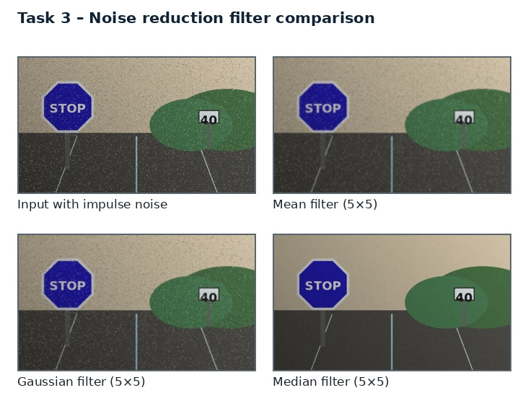
Figure 3. Illustrative comparison of mean, Gaussian and median smoothing.
Rain droplets, sensor grain, compression artefacts and isolated bright/dark specks can create false edges around traffic signs. Smoothing should reduce these disturbances while preserving thin sign borders, small numerals and pedestrian symbols.

Three candidate techniques
A. Box/mean filter. Averages every pixel in a neighbourhood. Simple and fast, but spreads rain and blurs narrow borders.
B. Gaussian filter. Uses distance-weighted averaging. Suppresses high-frequency noise smoothly and is useful before edge detection.
C. Median filter. Replaces a pixel with the neighbourhood median. Effective against isolated salt-and-pepper noise and preserves edges better at small kernels.
Common comparison rule. All three candidates must be applied to the same held-out frames, with identical input resolution, annotations and hardware. Parameters are tuned only on the validation split; the test split is used once for final reporting.

Evaluation dimension | How it is measured | Why it matters
Visual / local contrast | PSNR and SSIM against clean reference frames, sign-mask Dice, boundary F1, small-symbol retention, residual noise and runtime for 3×3, 5×5 and 7×7 kernels. | Connects image quality to the sign task.
Preservation | Mask overlap, boundary F1 or colour stability | Prevents attractive enhancement from damaging sign identity.
Efficiency | Mean and 95th-percentile milliseconds per frame | Averages can hide slow frames in live video.

TASK 3 – IMPLEMENTATION AND EXPERIMENT DESIGN
Use the same corrupted input for all filters. Test cv2.blur, cv2.GaussianBlur and cv2.medianBlur. Compare 3×3, 5×5 and 7×7. For rain streaks, add an optional directional detector; a median filter alone will not remove long streaks without damaging sign edges.

Implementation workflow
Noisy RGB frame
↓
Estimate noise type
↓
Median 3×3 for impulse noise
↓
Optional Gaussian 3×3 for grain
↓
Measure edge retention
↓
Filtered frame

Reference implementation fragment
# Apply per colour channel via OpenCV's colour-aware filtering
median = cv2.medianBlur(img, 3)
# Optional mild Gaussian only if sensor grain remains
gauss = cv2.GaussianBlur(median, (3, 3), 0.6)
# Compare median and Gaussian outputs against a clean reference during validation
The fragment illustrates the core operation and must be integrated with input validation, error handling, frame timing and parameter logging. Install OpenCV and NumPy in the same Python environment used for the final experiment. Check channel order (OpenCV reads BGR by default) and ensure that arrays are not accidentally modified in place.
TASK 3 – COMPARATIVE ANALYSIS
The following comparison is a structured engineering expectation for the candidate techniques. It is not a claim that the user's camera dataset has already been executed. Replace the qualitative entries with measured values after running the experiment.
Candidate | Main advantage | Main limitation | Role in proposed system
Box 3×3 | low cost | Softens sign border | Not preferred
Gaussian 3×3 | smooth noise suppression | Good for mild grain | Secondary
Median 3×3 | outlier removal | Best isolated-noise / edge balance | Preferred first pass

Recommended experiment matrix
Test subset | Stress condition | Primary observations
S1 | Bright sunlight / reflective glare | Clipping, border visibility, hue stability.
S2 | Night / headlights | Shadow recovery, noise, sign contrast.
S3 | Rain / wet lens | False edges, streak response, segmentation leakage.
S4 | Faded / weathered sign | Recall of weak border and low-saturation pixels.
S5 | Branch / partial obstruction | Visible-area accuracy, contour gaps, uncertainty.
S6 | Moving vehicle / blur | Boundary displacement, recognition stability, latency.

TASK 3 – RESULT INTERPRETATION AND FAILURE ANALYSIS
Large kernels remove more noise but can erase the 2–4 pixel details of small signs at distance. A median filter is robust to isolated specks, while Gaussian smoothing is more predictable for approximately Gaussian sensor noise. A two-stage process may be justified: median for isolated outliers followed by a very mild Gaussian only when grain remains.

Failure audit
- Sunlight and specular reflection: record the fraction of saturated pixels and verify that sign interiors do not become featureless.
- Night and shadow: verify that enhancement does not amplify noise enough to create false sign candidates.
- Rain and lens contamination: distinguish moving rain streaks from persistent lens spots and actual sign borders.
- Faded or damaged paint: check whether the method preserves weak but genuine boundary evidence.
- Partial occlusion: report visible-area fraction separately from any fitted complete geometric outline.
- Motion blur: compare current-frame quality with neighbouring frames and abstain when evidence is inadequate.
Failure mode | Likely cause | Mitigation / safe response
False positive | Road object shares colour or edge pattern | Geometry + temporal persistence; reject low score.
False negative | Faded border / glare / blur | Adaptive thresholds; multi-frame evidence; low-confidence state.
Boundary leakage | Branch or vehicle touches sign region | Shape prior, component filtering and occlusion flag.
Artificial detail | Over-enhancement or learned restoration | Keep original; compare edge locations; audit provenance.

A critical principle is that enhancement cannot recover information that is physically absent. If the sign is fully hidden or motion blur removes the symbol, the system should report uncertainty rather than generate a plausible-looking answer.
TASK 3 – FINAL DECISION AND EVIDENCE
Choose a 3×3 median filter as the default first-pass denoiser. Escalate to a 3×3 Gaussian for visible Gaussian grain only if edge retention remains acceptable. Do not use 7×7 smoothing on small or distant signs.

Decision table
Decision | Evidence-based justification | Consequence if not selected
Preferred: Median 3×3 | Best isolated-noise / edge balance | May reduce robustness or increase false detections.
Retain as support: Gaussian 3×3 | Useful in the conditions where its assumptions hold; retain as fallback or diagnostic. | A useful complementary cue may be lost.
Do not use alone: Box 3×3 | Its failure mode is not acceptable as the only stage in a variable road scene. | Colour/shape/visibility evidence may be damaged.

Evidence to attach after execution
- Original and processed frames from at least one example of each stress condition.
- A parameter table with exact values and the same values used for all compared frames.
- A numerical results table with mean, standard deviation and 95th-percentile runtime.
- A failure example with annotation and a short explanation of why the method failed.
- A saved configuration file and source-code version for repeatability.
Task conclusion. Choose a 3×3 median filter as the default first-pass denoiser. Escalate to a 3×3 Gaussian for visible Gaussian grain only if edge retention remains acceptable. Do not use 7×7 smoothing on small or distant signs.

TASK 4 – IMAGE SHARPENING AND EDGE ENHANCEMENT
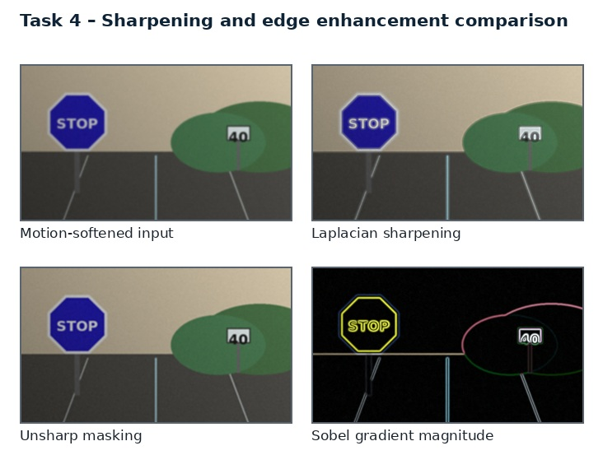
Figure 4. Illustrative comparison of Laplacian sharpening, unsharp masking and Sobel response.
A moving vehicle produces defocus and motion blur. The sign outline and internal symbols become soft, making localization and recognition less reliable. Sharpening can strengthen edges, but it can also amplify noise and create artificial halos.

Three candidate techniques
A. Laplacian sharpening. Uses a second derivative to emphasize rapid intensity changes. Strong response to fine detail and noise.
B. Unsharp masking / high-boost. Adds a scaled high-frequency residual: g=f+k(f−blur(f)). Strength is controlled by k and blur scale.
C. Sobel-gradient enhancement. Uses first derivatives in horizontal and vertical directions; can emphasize directional boundaries and corners.
Common comparison rule. All three candidates must be applied to the same held-out frames, with identical input resolution, annotations and hardware. Parameters are tuned only on the validation split; the test split is used once for final reporting.

Evaluation dimension | How it is measured | Why it matters
Visual / local contrast | Variance of Laplacian, boundary F1, edge overshoot/halo, residual noise, sign-mask Dice and recognition confidence/CER where labels exist. | Connects image quality to the sign task.
Preservation | Mask overlap, boundary F1 or colour stability | Prevents attractive enhancement from damaging sign identity.
Efficiency | Mean and 95th-percentile milliseconds per frame | Averages can hide slow frames in live video.

TASK 4 – IMPLEMENTATION AND EXPERIMENT DESIGN
Apply smoothing first, then sharpening. Compare Laplacian, unsharp masking with k=0.7–1.2 and Sobel magnitude. Keep values in float until clipping is deliberately applied. Preserve the unsharpened crop as an audit copy.

Implementation workflow
Figure – vertical processing sequence
Denoised sign candidate
↓
Estimate blur score
↓
If blur is moderate: unsharp mask
↓
Check halos + edge displacement
↓
Accept / revert to original
↓
Enhanced crop + provenance

Reference implementation fragment
base = cv2.medianBlur(img, 3)
blur = cv2.GaussianBlur(base, (0, 0), 1.0)
# f + k(f - blur(f)); use float arithmetic to avoid wrap-around
f = base.astype('float32')
sharp = np.clip(f + 0.8 * (f - blur.astype('float32')), 0, 255).astype('uint8')
The fragment illustrates the core operation and must be integrated with input validation, error handling, frame timing and parameter logging. Install OpenCV and NumPy in the same Python environment used for the final experiment. Check channel order (OpenCV reads BGR by default) and ensure that arrays are not accidentally modified in place.
TASK 4 – COMPARATIVE ANALYSIS
The following comparison is a structured engineering expectation for the candidate techniques. It is not a claim that the user's camera dataset has already been executed. Replace the qualitative entries with measured values after running the experiment.
Candidate | Main advantage | Main limitation | Role in proposed system
Laplacian | high-frequency boost | Noise and halos can increase | Diagnostic
Unsharp masking | controlled residual | Balanced sharpness and noise | Preferred
Sobel gradient | edge magnitude boost | May thicken/darken borders | Secondary

Recommended experiment matrix
Test subset | Stress condition | Primary observations
S1 | Bright sunlight / reflective glare | Clipping, border visibility, hue stability.
S2 | Night / headlights | Shadow recovery, noise, sign contrast.
S3 | Rain / wet lens | False edges, streak response, segmentation leakage.
S4 | Faded / weathered sign | Recall of weak border and low-saturation pixels.
S5 | Branch / partial obstruction | Visible-area accuracy, contour gaps, uncertainty.
S6 | Moving vehicle / blur | Boundary displacement, recognition stability, latency.

For each subset, report the number of frames, number of signs, sign classes, image resolution, camera source and train/validation/test split. Keep consecutive frames from the same video sequence in only one split to avoid data leakage.
TASK 4 – RESULT INTERPRETATION AND FAILURE ANALYSIS
Second derivatives respond strongly to high-frequency components, including sensor grain. Unsharp masking is easier to tune and can be restricted to the sign crop. Sharpening cannot reverse severe motion blur because lost frequencies are not present in the frame. A learned deblurring model may help but can hallucinate sign characters.

Failure audit
- Sunlight and specular reflection: record the fraction of saturated pixels and verify that sign interiors do not become featureless.
- Night and shadow: verify that enhancement does not amplify noise enough to create false sign candidates.
- Rain and lens contamination: distinguish moving rain streaks from persistent lens spots and actual sign borders.
- Faded or damaged paint: check whether the method preserves weak but genuine boundary evidence.
- Partial occlusion: report visible-area fraction separately from any fitted complete geometric outline.
- Motion blur: compare current-frame quality with neighbouring frames and abstain when evidence is inadequate.
Failure mode | Likely cause | Mitigation / safe response
False positive | Road object shares colour or edge pattern | Geometry + temporal persistence; reject low score.
False negative | Faded border / glare / blur | Adaptive thresholds; multi-frame evidence; low-confidence state.
Boundary leakage | Branch or vehicle touches sign region | Shape prior, component filtering and occlusion flag.
Artificial detail | Over-enhancement or learned restoration | Keep original; compare edge locations; audit provenance.

A critical principle is that enhancement cannot recover information that is physically absent. If the sign is fully hidden or motion blur removes the symbol, the system should report uncertainty rather than generate a plausible-looking answer.
TASK 4 – FINAL DECISION AND EVIDENCE
Choose mild unsharp masking after denoising, with k near 0.8 and a small Gaussian blur scale. Apply only when a blur score crosses a threshold. Never replace the original frame; mark the enhanced crop as a derived image.

Decision table
Decision | Evidence-based justification | Consequence if not selected
Preferred: Sobel gradient | May thicken/darken borders | May reduce robustness or increase false detections.
Retain as support: Unsharp masking | Useful in the conditions where its assumptions hold; retain as fallback or diagnostic. | A useful complementary cue may be lost.
Do not use alone: Laplacian | Its failure mode is not acceptable as the only stage in a variable road scene. | Colour/shape/visibility evidence may be damaged.

Evidence to attach after execution
- Original and processed frames from at least one example of each stress condition.
- A parameter table with exact values and the same values used for all compared frames.
- A numerical results table with mean, standard deviation and 95th-percentile runtime.
- A failure example with annotation and a short explanation of why the method failed.
- A saved configuration file and source-code version for repeatability.
Task conclusion. Choose mild unsharp masking after denoising, with k near 0.8 and a small Gaussian blur scale. Apply only when a blur score crosses a threshold. Never replace the original frame; mark the enhanced crop as a derived image.

TASK 5 – FREQUENCY-DOMAIN LOW-PASS FILTERING
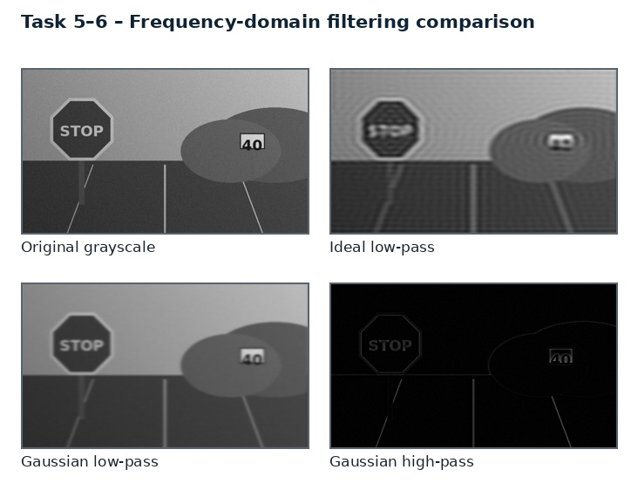
Figure 5. Illustrative frequency-domain low-pass and high-pass filtering outputs.
Some camera sensors and video encoders create periodic banding; rain and fine texture also contribute high-frequency components. Frequency-domain filtering can suppress selected frequencies, but broad low-pass filtering may blur small sign details.

Three candidate techniques
A. Ideal low-pass filter. Passes all frequencies inside D0 and rejects all frequencies outside. Abrupt cut-off causes ringing.
B. Butterworth low-pass filter. Smooth transition controlled by order n; balances sharpness and ringing.
C. Gaussian low-pass filter. Smooth frequency response with minimal ringing; predictable but may blur small details.
Common comparison rule. All three candidates must be applied to the same held-out frames, with identical input resolution, annotations and hardware. Parameters are tuned only on the validation split; the test split is used once for final reporting.

Evaluation dimension | How it is measured | Why it matters
Visual / local contrast | Log-magnitude spectrum, periodic-noise amplitude, edge transition width, ringing overshoot, SSIM, boundary F1 and processing time. | Connects image quality to the sign task.
Preservation | Mask overlap, boundary F1 or colour stability | Prevents attractive enhancement from damaging sign identity.
Efficiency | Mean and 95th-percentile milliseconds per frame | Averages can hide slow frames in live video.

TASK 5 – IMPLEMENTATION AND EXPERIMENT DESIGN
Pad the image, compute FFT, shift zero frequency to the centre, multiply by H(u,v), inverse shift and inverse FFT, then crop. Use D0 sweep at low/medium/high values. For known periodic banding, compare a narrow notch filter as an additional engineering alternative.

Implementation workflow
Figure – vertical processing sequence
Frame / sign crop
↓
Pad + window
↓
FFT + centred log spectrum
↓
Select Gaussian LPF / notch
↓
Inverse FFT + crop
↓
Check edge width + ringing

Reference implementation fragment
f = img.astype(np.float32)
F = np.fft.fftshift(np.fft.fft2(f))
rows, cols = f.shape
Y, X = np.ogrid[:rows, :cols]
D2 = (Y-rows/2)**2 + (X-cols/2)**2
D0 = 90.0
H = np.exp(-D2 / (2.0 * D0 * D0))
out = np.real(np.fft.ifft2(np.fft.ifftshift(F * H)))
out = np.clip(out, 0, 255).astype(np.uint8)
The fragment illustrates the core operation and must be integrated with input validation, error handling, frame timing and parameter logging. Install OpenCV and NumPy in the same Python environment used for the final experiment. Check channel order (OpenCV reads BGR by default) and ensure that arrays are not accidentally modified in place.
TASK 5 – COMPARATIVE ANALYSIS
The following comparison is a structured engineering expectation for the candidate techniques. It is not a claim that the user's camera dataset has already been executed. Replace the qualitative entries with measured values after running the experiment.
Candidate | Main advantage | Main limitation | Role in proposed system
Ideal LPF | hard cut-off | Most ringing | Avoid
Butterworth n=2 | gradual cut-off | Moderate ringing | Alternative
Gaussian LPF | smooth response | Least ringing; some blur | Preferred if low-pass required

Recommended experiment matrix
Test subset | Stress condition | Primary observations
S1 | Bright sunlight / reflective glare | Clipping, border visibility, hue stability.
S2 | Night / headlights | Shadow recovery, noise, sign contrast.
S3 | Rain / wet lens | False edges, streak response, segmentation leakage.
S4 | Faded / weathered sign | Recall of weak border and low-saturation pixels.
S5 | Branch / partial obstruction | Visible-area accuracy, contour gaps, uncertainty.
S6 | Moving vehicle / blur | Boundary displacement, recognition stability, latency.

For each subset, report the number of frames, number of signs, sign classes, image resolution, camera source and train/validation/test split. Keep consecutive frames from the same video sequence in only one split to avoid data leakage.
TASK 5 – RESULT INTERPRETATION AND FAILURE ANALYSIS
A global low-pass filter removes detail in every direction. If periodic interference has a known frequency, a notch filter can suppress that frequency while retaining most sign edges. The FFT treats the image as periodic, so padding is essential to reduce wrap-around artefacts.

Failure audit
- Sunlight and specular reflection: record the fraction of saturated pixels and verify that sign interiors do not become featureless.
- Night and shadow: verify that enhancement does not amplify noise enough to create false sign candidates.
- Rain and lens contamination: distinguish moving rain streaks from persistent lens spots and actual sign borders.
- Faded or damaged paint: check whether the method preserves weak but genuine boundary evidence.
- Partial occlusion: report visible-area fraction separately from any fitted complete geometric outline.
- Motion blur: compare current-frame quality with neighbouring frames and abstain when evidence is inadequate.
Failure mode | Likely cause | Mitigation / safe response
False positive | Road object shares colour or edge pattern | Geometry + temporal persistence; reject low score.
False negative | Faded border / glare / blur | Adaptive thresholds; multi-frame evidence; low-confidence state.
Boundary leakage | Branch or vehicle touches sign region | Shape prior, component filtering and occlusion flag.
Artificial detail | Over-enhancement or learned restoration | Keep original; compare edge locations; audit provenance.

A critical principle is that enhancement cannot recover information that is physically absent. If the sign is fully hidden or motion blur removes the symbol, the system should report uncertainty rather than generate a plausible-looking answer.
TASK 5 – FINAL DECISION AND EVIDENCE
Use Gaussian low-pass only for broad high-frequency noise when the sign is large enough to tolerate slight blur. Prefer a narrow notch for stable periodic banding. Do not use a strong low-pass on distant signs.

Decision table
Decision | Evidence-based justification | Consequence if not selected
Preferred: Gaussian LPF | Least ringing; some blur | May reduce robustness or increase false detections.
Retain as support: Butterworth n=2 | Useful in the conditions where its assumptions hold; retain as fallback or diagnostic. | A useful complementary cue may be lost.
Do not use alone: Ideal LPF | Its failure mode is not acceptable as the only stage in a variable road scene. | Colour/shape/visibility evidence may be damaged.

Evidence to attach after execution
- Original and processed frames from at least one example of each stress condition.
- A parameter table with exact values and the same values used for all compared frames.
- A numerical results table with mean, standard deviation and 95th-percentile runtime.
- A failure example with annotation and a short explanation of why the method failed.
- A saved configuration file and source-code version for repeatability.
Task conclusion. Use Gaussian low-pass only for broad high-frequency noise when the sign is large enough to tolerate slight blur. Prefer a narrow notch for stable periodic banding. Do not use a strong low-pass on distant signs.

TASK 6 – FREQUENCY-DOMAIN HIGH-PASS FILTERING
Shadows and gradual exposure gradients affect low spatial frequencies, while sign borders and pictograms contain higher-frequency information. High-pass approaches can highlight edges but may remove the average brightness needed to interpret sign colours.

Three candidate techniques
A. Ideal / Butterworth high-pass. Complement of a low-pass response. Removes low frequencies; ideal version can create ringing.
B. High-frequency emphasis. H=a+bHhp preserves part of the low-frequency component while strengthening high-frequency detail.
C. Homomorphic filtering. Uses f=i×r; log converts illumination and reflectance into additive components. Attenuates slow illumination and preserves detail.
Common comparison rule. All three candidates must be applied to the same held-out frames, with identical input resolution, annotations and hardware. Parameters are tuned only on the validation split; the test split is used once for final reporting.
Evaluation dimension | How it is measured | Why it matters
Visual / local contrast | Sign/background contrast, illumination evenness, DC/mean brightness preservation, colour stability, noise amplification and boundary F1. | Connects image quality to the sign task.
Preservation | Mask overlap, boundary F1 or colour stability | Prevents attractive enhancement from damaging sign identity.
Efficiency | Mean and 95th-percentile milliseconds per frame | Averages can hide slow frames in live video.

TASK 6 – IMPLEMENTATION AND EXPERIMENT DESIGN
Apply on luminance, not independently on RGB channels. Use a Butterworth or Gaussian high-pass; for homomorphic filtering use log1p, frequency emphasis, inverse transform and expm1. Re-normalize conservatively and retain colour channels.

Implementation workflow

RGB sign crop
↓
Extract luminance + log transform
↓
Frequency emphasis: γL < 1, γH > 1
↓
Inverse FFT + exponentiate
↓
Restore chroma / validate colour
↓
Shadow-corrected crop

Reference implementation fragment
L = cv2.cvtColor(img, cv2.COLOR_BGR2LAB)[:,:,0].astype(np.float32)
logL = np.log1p(L)
F = np.fft.fftshift(np.fft.fft2(logL))
# Construct Gaussian high-frequency emphasis transfer function H
# H = (gh-gl)*(1-exp(-D^2/D0^2)) + gl
# Apply H, inverse FFT, expm1, then normalize within safe luminance limits
The fragment illustrates the core operation and must be integrated with input validation, error handling, frame timing and parameter logging. Install OpenCV and NumPy in the same Python environment used for the final experiment. Check channel order (OpenCV reads BGR by default) and ensure that arrays are not accidentally modified in place.
TASK 6 – COMPARATIVE ANALYSIS
The following comparison is a structured engineering expectation for the candidate techniques. It is not a claim that the user's camera dataset has already been executed. Replace the qualitative entries with measured values after running the experiment.
Candidate | Main advantage | Main limitation | Role in proposed system
Plain HPF | removes DC / slow illumination | Edges visible, sign colour lost | Not final image
High-frequency emphasis | preserves DC fraction | Good detail with tone retained | Secondary
Homomorphic | illumination-reflectance model | Best shadow correction potential | Preferred

Recommended experiment matrix
Test subset | Stress condition | Primary observations
S1 | Bright sunlight / reflective glare | Clipping, border visibility, hue stability.
S2 | Night / headlights | Shadow recovery, noise, sign contrast.
S3 | Rain / wet lens | False edges, streak response, segmentation leakage.
S4 | Faded / weathered sign | Recall of weak border and low-saturation pixels.
S5 | Branch / partial obstruction | Visible-area accuracy, contour gaps, uncertainty.
S6 | Moving vehicle / blur | Boundary displacement, recognition stability, latency.

For each subset, report the number of frames, number of signs, sign classes, image resolution, camera source and train/validation/test split. Keep consecutive frames from the same video sequence in only one split to avoid data leakage.
TASK 6 – RESULT INTERPRETATION AND FAILURE ANALYSIS
Plain HPF can produce a near-zero mean image and remove the red/blue/yellow sign identity. High-frequency emphasis retains some base tone. Homomorphic filtering explicitly models illumination as slowly varying and reflectance as containing sign detail, but incorrect gain settings can exaggerate noise or flatten the sign interior.

Failure audit
- Sunlight and specular reflection: record the fraction of saturated pixels and verify that sign interiors do not become featureless.
- Night and shadow: verify that enhancement does not amplify noise enough to create false sign candidates.
- Rain and lens contamination: distinguish moving rain streaks from persistent lens spots and actual sign borders.
- Faded or damaged paint: check whether the method preserves weak but genuine boundary evidence.
- Partial occlusion: report visible-area fraction separately from any fitted complete geometric outline.
- Motion blur: compare current-frame quality with neighbouring frames and abstain when evidence is inadequate.

Failure mode | Likely cause | Mitigation / safe response
False positive | Road object shares colour or edge pattern | Geometry + temporal persistence; reject low score.
False negative | Faded border / glare / blur | Adaptive thresholds; multi-frame evidence; low-confidence state.
Boundary leakage | Branch or vehicle touches sign region | Shape prior, component filtering and occlusion flag.
Artificial detail | Over-enhancement or learned restoration | Keep original; compare edge locations; audit provenance.

A critical principle is that enhancement cannot recover information that is physically absent. If the sign is fully hidden or motion blur removes the symbol, the system should report uncertainty rather than generate a plausible-looking answer.

TASK 6 – FINAL DECISION AND EVIDENCE
Choose homomorphic luminance correction with conservative low/high gains, followed by colour consistency checks. Use high-frequency emphasis as a simpler fallback. Never feed a raw high-pass-only image to the recognition model.

Decision table
Decision | Evidence-based justification | Consequence if not selected
Preferred: Homomorphic | Best shadow correction potential | May reduce robustness or increase false detections.
Retain as support: High-frequency emphasis | Useful in the conditions where its assumptions hold; retain as fallback or diagnostic. | A useful complementary cue may be lost.
Do not use alone: Plain HPF | Its failure mode is not acceptable as the only stage in a variable road scene. | Colour/shape/visibility evidence may be damaged.

Evidence to attach after execution
- Original and processed frames from at least one example of each stress condition.
- A parameter table with exact values and the same values used for all compared frames.
- A numerical results table with mean, standard deviation and 95th-percentile runtime.
- A failure example with annotation and a short explanation of why the method failed.
- A saved configuration file and source-code version for repeatability.
Task conclusion. Choose homomorphic luminance correction with conservative low/high gains, followed by colour consistency checks. Use high-frequency emphasis as a simpler fallback. Never feed a raw high-pass-only image to the recognition model.

TASK 7 – POINT, LINE AND EDGE DETECTION
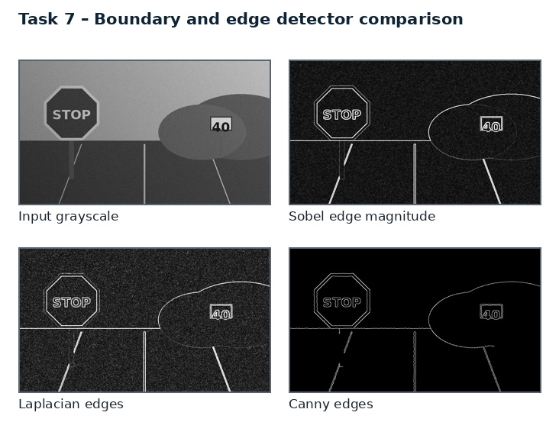
Figure 6. Illustrative comparison of Sobel, Laplacian and Canny edge maps.
Traffic signs have recognizable geometric boundaries: STOP signs are octagonal, warning signs are often triangular, speed-limit signs are circular, and No Entry signs are circular with a horizontal bar. Detecting these structures helps isolate a sign before classification.

Three candidate techniques
A. Point / corner detectors. Harris or Shi–Tomasi corners identify vertices and high-curvature junctions; useful for polygon corners but sensitive to texture.
B. Line detectors. Sobel/Hough line detection identifies straight sign edges and internal bars; useful for triangular/rectangular signs.
C. Edge detectors. Canny combines smoothing, gradient estimation, non-maximum suppression and hysteresis; suitable for closed sign contours.
Common comparison rule. All three candidates must be applied to the same held-out frames, with identical input resolution, annotations and hardware. Parameters are tuned only on the validation split; the test split is used once for final reporting.

Evaluation dimension | How it is measured | Why it matters
Visual / local contrast | Precision, recall and F1 with 2–3 px tolerance; contour closure rate; corner localization error; false edges per frame; runtime. | Connects image quality to the sign task.
Preservation | Mask overlap, boundary F1 or colour stability | Prevents attractive enhancement from damaging sign identity.
Efficiency | Mean and 95th-percentile milliseconds per frame | Averages can hide slow frames in live video.

TASK 7 – IMPLEMENTATION AND EXPERIMENT DESIGN
Denoise lightly, compute Canny edges at adaptive thresholds, then use Hough lines for straight segments and contour geometry for circles/polygons. Use colour masks as a complementary cue rather than a hard prerequisite.

Implementation workflow

Enhanced frame
↓
Canny edge map
↓
Contours + Hough line candidates
↓
Fit circle / triangle / octagon / rectangle
↓
Score geometry + colour + time
↓
Sign boundary candidates

Reference implementation fragment
gray = cv2.cvtColor(img, cv2.COLOR_BGR2GRAY)
gray = cv2.GaussianBlur(gray, (3,3), 0.8)
med = np.median(gray)
low = int(max(0, 0.66 * med)); high = int(min(255, 1.33 * med))
edges = cv2.Canny(gray, low, high)
contours, _ = cv2.findContours(edges, cv2.RETR_EXTERNAL, cv2.CHAIN_APPROX_SIMPLE)
The fragment illustrates the core operation and must be integrated with input validation, error handling, frame timing and parameter logging. Install OpenCV and NumPy in the same Python environment used for the final experiment. Check channel order (OpenCV reads BGR by default) and ensure that arrays are not accidentally modified in place.
TASK 7 – COMPARATIVE ANALYSIS
The following comparison is a structured engineering expectation for the candidate techniques. It is not a claim that the user's camera dataset has already been executed. Replace the qualitative entries with measured values after running the experiment.
Candidate | Main advantage | Main limitation | Role in proposed system
Harris/Shi–Tomasi | corner localization | Good for polygon vertices; texture false positives | Use selectively
Hough lines | straight edges / bars | Good for STOP edges and No Entry bar | Geometry support
Canny + contours | continuous boundary | Strong general boundary map | Preferred base

Recommended experiment matrix
Test subset | Stress condition | Primary observations
S1 | Bright sunlight / reflective glare | Clipping, border visibility, hue stability.
S2 | Night / headlights | Shadow recovery, noise, sign contrast.
S3 | Rain / wet lens | False edges, streak response, segmentation leakage.
S4 | Faded / weathered sign | Recall of weak border and low-saturation pixels.
S5 | Branch / partial obstruction | Visible-area accuracy, contour gaps, uncertainty.
S6 | Moving vehicle / blur | Boundary displacement, recognition stability, latency.

For each subset, report the number of frames, number of signs, sign classes, image resolution, camera source and train/validation/test split. Keep consecutive frames from the same video sequence in only one split to avoid data leakage.
TASK 7 – RESULT INTERPRETATION AND FAILURE ANALYSIS
Canny alone does not understand a sign. A branch may produce a stronger edge than a faded border. Hough line detection can miss curved circular signs. Corner detectors may return many points on letters or road texture. Combine edge continuity, expected shape, colour and temporal persistence.

Failure audit
- Sunlight and specular reflection: record the fraction of saturated pixels and verify that sign interiors do not become featureless.
- Night and shadow: verify that enhancement does not amplify noise enough to create false sign candidates.
- Rain and lens contamination: distinguish moving rain streaks from persistent lens spots and actual sign borders.
- Faded or damaged paint: check whether the method preserves weak but genuine boundary evidence.
- Partial occlusion: report visible-area fraction separately from any fitted complete geometric outline.
- Motion blur: compare current-frame quality with neighbouring frames and abstain when evidence is inadequate.
Failure mode | Likely cause | Mitigation / safe response
False positive | Road object shares colour or edge pattern | Geometry + temporal persistence; reject low score.
False negative | Faded border / glare / blur | Adaptive thresholds; multi-frame evidence; low-confidence state.
Boundary leakage | Branch or vehicle touches sign region | Shape prior, component filtering and occlusion flag.
Artificial detail | Over-enhancement or learned restoration | Keep original; compare edge locations; audit provenance.

A critical principle is that enhancement cannot recover information that is physically absent. If the sign is fully hidden or motion blur removes the symbol, the system should report uncertainty rather than generate a plausible-looking answer.
TASK 7 – FINAL DECISION AND EVIDENCE
Choose Canny as the base edge map, with Hough lines and corner/contour geometry as shape-specific refinements. Reject detections that do not satisfy plausible sign aspect ratio, polygon/circle fit and temporal consistency.

Decision table
Decision | Evidence-based justification | Consequence if not selected
Preferred: Canny + contours | Strong general boundary map | May reduce robustness or increase false detections.
Retain as support: Hough lines | Useful in the conditions where its assumptions hold; retain as fallback or diagnostic. | A useful complementary cue may be lost.
Do not use alone: Harris/Shi–Tomasi | Its failure mode is not acceptable as the only stage in a variable road scene. | Colour/shape/visibility evidence may be damaged.

Evidence to attach after execution
- Original and processed frames from at least one example of each stress condition.
- A parameter table with exact values and the same values used for all compared frames.
- A numerical results table with mean, standard deviation and 95th-percentile runtime.
- A failure example with annotation and a short explanation of why the method failed.
- A saved configuration file and source-code version for repeatability.
Task conclusion. Choose Canny as the base edge map, with Hough lines and corner/contour geometry as shape-specific refinements. Reject detections that do not satisfy plausible sign aspect ratio, polygon/circle fit and temporal consistency.

TASK 8 – IMAGE THRESHOLDING AND BINARIZATION
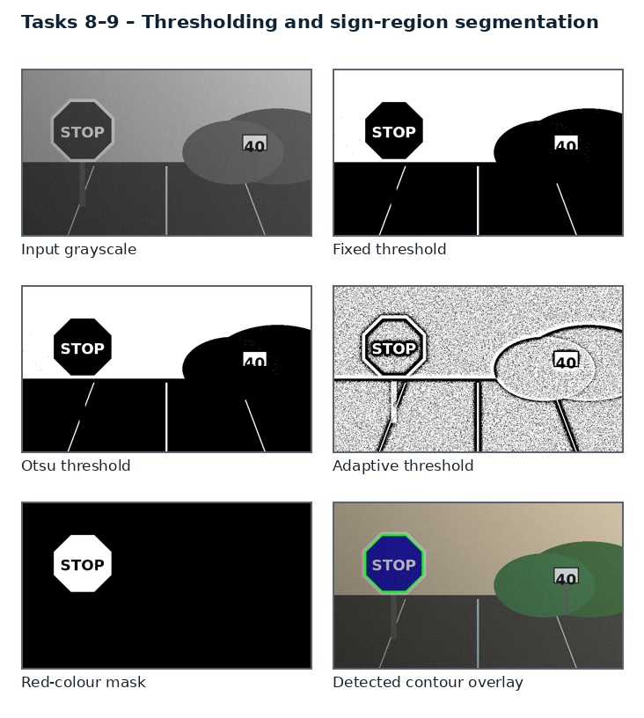
Figure 7. Illustrative comparison of fixed, Otsu and adaptive thresholding, plus colour-mask segmentation.
Thresholding separates candidate sign pixels from the background. Unlike document images, traffic signs are coloured and reflective; intensity-only thresholding can fail under changing exposure. Colour spaces and local thresholds provide complementary information.

Three candidate techniques
A. Fixed/global threshold. Applies a fixed intensity or HSV range. Fast and interpretable, but fragile under lighting and camera white-balance changes.
B. Otsu thresholding. Selects a global threshold by maximizing between-class variance. Useful when foreground/background distributions are separable.
C. Adaptive threshold / colour mask. Uses local statistics or HSV/Lab colour ranges; can handle local lighting but may include similarly coloured vehicles, buildings or road paint.
Common comparison rule. All three candidates must be applied to the same held-out frames, with identical input resolution, annotations and hardware. Parameters are tuned only on the validation split; the test split is used once for final reporting.
Evaluation dimension | How it is measured | Why it matters
Visual / local contrast | Sign-mask Dice and IoU, precision/recall, false-positive area, missed faded pixels, colour stability and runtime. | Connects image quality to the sign task.
Preservation | Mask overlap, boundary F1 or colour stability | Prevents attractive enhancement from damaging sign identity.
Efficiency | Mean and 95th-percentile milliseconds per frame | Averages can hide slow frames in live video.

TASK 8 – IMPLEMENTATION AND EXPERIMENT DESIGN
Create red, blue, yellow and white candidate masks in HSV/Lab; use adaptive luminance threshold for low-contrast borders. Morphological opening/closing repairs small gaps. Keep separate masks per sign colour family and merge only after geometry checks.

Implementation workflow
Enhanced RGB frame
↓
HSV + Lab conversion
↓
Colour-family candidate masks
↓
Adaptive luminance support
↓
Morphological cleanup
↓
Shape / contour validation

Reference implementation fragment
hsv = cv2.cvtColor(img, cv2.COLOR_BGR2HSV)
# Example red hue wrap-around mask; tune for camera calibration
red1 = cv2.inRange(hsv, (0, 45, 45), (12, 255, 255))
red2 = cv2.inRange(hsv, (168, 35, 40), (180, 255, 255))
red_mask = cv2.bitwise_or(red1, red2)
k = cv2.getStructuringElement(cv2.MORPH_ELLIPSE, (3,3))
red_mask = cv2.morphologyEx(red_mask, cv2.MORPH_CLOSE, k)
The fragment illustrates the core operation and must be integrated with input validation, error handling, frame timing and parameter logging. Install OpenCV and NumPy in the same Python environment used for the final experiment. Check channel order (OpenCV reads BGR by default) and ensure that arrays are not accidentally modified in place.
TASK 8 – COMPARATIVE ANALYSIS
The following comparison is a structured engineering expectation for the candidate techniques. It is not a claim that the user's camera dataset has already been executed. Replace the qualitative entries with measured values after running the experiment.
Candidate | Main advantage | Main limitation | Role in proposed system
Fixed/global | single threshold | Fast but exposure-sensitive | Baseline
Otsu | automatic global T | Good if bimodal; weak in mixed scenes | Secondary
Adaptive + colour | local luminance + hue | Best flexible candidate mask | Preferred

Recommended experiment matrix
Test subset | Stress condition | Primary observations
S1 | Bright sunlight / reflective glare | Clipping, border visibility, hue stability.
S2 | Night / headlights | Shadow recovery, noise, sign contrast.
S3 | Rain / wet lens | False edges, streak response, segmentation leakage.
S4 | Faded / weathered sign | Recall of weak border and low-saturation pixels.
S5 | Branch / partial obstruction | Visible-area accuracy, contour gaps, uncertainty.
S6 | Moving vehicle / blur | Boundary displacement, recognition stability, latency.

For each subset, report the number of frames, number of signs, sign classes, image resolution, camera source and train/validation/test split. Keep consecutive frames from the same video sequence in only one split to avoid data leakage.
TASK 8 – RESULT INTERPRETATION AND FAILURE ANALYSIS
A red vehicle or advertisement can pass a red colour threshold. A yellow street lamp or road marking can pass a yellow mask. Shape, location, edge closure and temporal persistence are needed to distinguish signs. Faded paint may have low saturation, so a strict saturation floor can reject real signs.

Failure audit
- Sunlight and specular reflection: record the fraction of saturated pixels and verify that sign interiors do not become featureless.
- Night and shadow: verify that enhancement does not amplify noise enough to create false sign candidates.
- Rain and lens contamination: distinguish moving rain streaks from persistent lens spots and actual sign borders.
- Faded or damaged paint: check whether the method preserves weak but genuine boundary evidence.
- Partial occlusion: report visible-area fraction separately from any fitted complete geometric outline.
- Motion blur: compare current-frame quality with neighbouring frames and abstain when evidence is inadequate.
Failure mode | Likely cause | Mitigation / safe response
False positive | Road object shares colour or edge pattern | Geometry + temporal persistence; reject low score.
False negative | Faded border / glare / blur | Adaptive thresholds; multi-frame evidence; low-confidence state.
Boundary leakage | Branch or vehicle touches sign region | Shape prior, component filtering and occlusion flag.
Artificial detail | Over-enhancement or learned restoration | Keep original; compare edge locations; audit provenance.

A critical principle is that enhancement cannot recover information that is physically absent. If the sign is fully hidden or motion blur removes the symbol, the system should report uncertainty rather than generate a plausible-looking answer.

TASK 8 – FINAL DECISION AND EVIDENCE
Choose a hybrid adaptive luminance and broad HSV/Lab colour mask, followed by geometric validation. Keep hue intervals tolerant and include a low-saturation faded-sign path. Use Otsu only inside a candidate crop, not across the whole road frame.

Decision table
Decision | Evidence-based justification | Consequence if not selected
Preferred: Adaptive + colour | Best flexible candidate mask | May reduce robustness or increase false detections.
Retain as support: Otsu | Useful in the conditions where its assumptions hold; retain as fallback or diagnostic. | A useful complementary cue may be lost.
Do not use alone: Fixed/global | Its failure mode is not acceptable as the only stage in a variable road scene. | Colour/shape/visibility evidence may be damaged.

Evidence to attach after execution
- Original and processed frames from at least one example of each stress condition.
- A parameter table with exact values and the same values used for all compared frames.
- A numerical results table with mean, standard deviation and 95th-percentile runtime.
- A failure example with annotation and a short explanation of why the method failed.
- A saved configuration file and source-code version for repeatability.
Task conclusion. Choose a hybrid adaptive luminance and broad HSV/Lab colour mask, followed by geometric validation. Keep hue intervals tolerant and include a low-saturation faded-sign path. Use Otsu only inside a candidate crop, not across the whole road frame.

TASK 9 – REGION-BASED SEGMENTATION AND INTEGRATED PIPELINE
The system must isolate the complete sign region, not merely detect a few edge pixels. It must preserve sign interiors, estimate the outer boundary, distinguish partial occlusion and produce a crop for recognition.

Three candidate techniques
A. Region growing. Starts from a seed in the sign and expands to neighbouring pixels with similar colour/intensity. Fast for homogeneous regions but seed-sensitive.
B. Watershed segmentation. Uses image gradients and markers to divide regions. Can separate touching objects but over-segments without good markers.
C. Edge linking + contour geometry. Links boundaries, extracts contours and fits expected sign shapes. Effective for structured sign borders but needs gap handling.
Common comparison rule. All three candidates must be applied to the same held-out frames, with identical input resolution, annotations and hardware. Parameters are tuned only on the validation split; the test split is used once for final reporting.
Evaluation dimension | How it is measured | Why it matters
Visual / local contrast | Sign-region IoU/Dice, boundary F1, corner/centre error, visible-area estimation error, occlusion robustness, false merge rate and latency. | Connects image quality to the sign task.
Preservation | Mask overlap, boundary F1 or colour stability | Prevents attractive enhancement from damaging sign identity.
Efficiency | Mean and 95th-percentile milliseconds per frame | Averages can hide slow frames in live video.

TASK 9 – IMPLEMENTATION AND EXPERIMENT DESIGN
Build candidate masks from Task 8, use morphology to remove small components, then apply watershed or contour refinement. Fit polygon/circle geometry and estimate occlusion gaps. Do not fill hidden areas as observed pixels; maintain visible mask separately from inferred outline.

Implementation workflow
Candidate mask (Task 8)
↓
Connected components + morphology
↓
Edge linking / contour extraction
↓
Fit expected sign geometry
↓
Estimate visible area + occlusion
↓
Rectified crop + mask + confidence

Reference implementation fragment
# Candidate component -> contour -> polygon approximation
cnts, _ = cv2.findContours(mask, cv2.RETR_EXTERNAL, cv2.CHAIN_APPROX_SIMPLE)
for c in cnts:
area = cv2.contourArea(c)
if area < 120: continue
peri = cv2.arcLength(c, True)
approx = cv2.approxPolyDP(c, 0.02 * peri, True)
x,y,w,h = cv2.boundingRect(approx)
aspect = w / float(h + 1e-6)
# retain plausible geometry; then score circularity / polygon fit / colour
The fragment illustrates the core operation and must be integrated with input validation, error handling, frame timing and parameter logging. Install OpenCV and NumPy in the same Python environment used for the final experiment. Check channel order (OpenCV reads BGR by default) and ensure that arrays are not accidentally modified in place.

TASK 9 – COMPARATIVE ANALYSIS
The following comparison is a structured engineering expectation for the candidate techniques. It is not a claim that the user's camera dataset has already been executed. Replace the qualitative entries with measured values after running the experiment.
Candidate | Main advantage | Main limitation | Role in proposed system
Region growing | homogeneous colour region | Seed leakage under shadow/branch | Use for interiors
Watershed | marker-based separation | Can over-segment borders and symbols | Conditional
Edge linking + contours | geometry-aware boundary | Strong sign-shape fit; gap sensitive | Preferred framework

Recommended experiment matrix
Test subset | Stress condition | Primary observations
S1 | Bright sunlight / reflective glare | Clipping, border visibility, hue stability.
S2 | Night / headlights | Shadow recovery, noise, sign contrast.
S3 | Rain / wet lens | False edges, streak response, segmentation leakage.
S4 | Faded / weathered sign | Recall of weak border and low-saturation pixels.
S5 | Branch / partial obstruction | Visible-area accuracy, contour gaps, uncertainty.
S6 | Moving vehicle / blur | Boundary displacement, recognition stability, latency.

For each subset, report the number of frames, number of signs, sign classes, image resolution, camera source and train/validation/test split. Keep consecutive frames from the same video sequence in only one split to avoid data leakage.

TASK 9 – RESULT INTERPRETATION AND FAILURE ANALYSIS
Traffic signs often have a strong outer border and relatively uniform interior. Region growing can leak into a similarly coloured vehicle or sky. Watershed can split one sign into many pieces if markers are poor. Edge linking plus shape fitting exploits known geometry and supports partial boundary observations. A visible mask must remain distinct from a hypothesized complete sign outline.

Failure audit
- Sunlight and specular reflection: record the fraction of saturated pixels and verify that sign interiors do not become featureless.
- Night and shadow: verify that enhancement does not amplify noise enough to create false sign candidates.
- Rain and lens contamination: distinguish moving rain streaks from persistent lens spots and actual sign borders.
- Faded or damaged paint: check whether the method preserves weak but genuine boundary evidence.
- Partial occlusion: report visible-area fraction separately from any fitted complete geometric outline.
- Motion blur: compare current-frame quality with neighbouring frames and abstain when evidence is inadequate.
Failure mode | Likely cause | Mitigation / safe response
False positive | Road object shares colour or edge pattern | Geometry + temporal persistence; reject low score.
False negative | Faded border / glare / blur | Adaptive thresholds; multi-frame evidence; low-confidence state.
Boundary leakage | Branch or vehicle touches sign region | Shape prior, component filtering and occlusion flag.
Artificial detail | Over-enhancement or learned restoration | Keep original; compare edge locations; audit provenance.

A critical principle is that enhancement cannot recover information that is physically absent. If the sign is fully hidden or motion blur removes the symbol, the system should report uncertainty rather than generate a plausible-looking answer.

TASK 9 – FINAL DECISION AND EVIDENCE
Choose colour-supported edge linking and contour fitting as the primary segmentation method; use watershed only for touching/overlapping candidate objects and region growing for uniform interiors. Feed the crop and visibility metadata to the recognition model.

Decision table
Decision | Evidence-based justification | Consequence if not selected
Preferred: Edge linking + contours | Strong sign-shape fit; gap sensitive | May reduce robustness or increase false detections.
Retain as support: Watershed | Useful in the conditions where its assumptions hold; retain as fallback or diagnostic. | A useful complementary cue may be lost.
Do not use alone: Region growing | Its failure mode is not acceptable as the only stage in a variable road scene. | Colour/shape/visibility evidence may be damaged.

Evidence to attach after execution
- Original and processed frames from at least one example of each stress condition.
- A parameter table with exact values and the same values used for all compared frames.
- A numerical results table with mean, standard deviation and 95th-percentile runtime.
- A failure example with annotation and a short explanation of why the method failed.
- A saved configuration file and source-code version for repeatability.
Task conclusion. Choose colour-supported edge linking and contour fitting as the primary segmentation method; use watershed only for touching/overlapping candidate objects and region growing for uniform interiors. Feed the crop and visibility metadata to the recognition model.

TASK 10 – ADAPTATION FOR MOVING-VEHICLE AND HIGH-RESOLUTION IMAGES
A roadside camera and a moving vehicle produce different image statistics. Motion blur, rolling shutter, perspective, vibration, changing scale, rain on the lens and partial occlusion challenge a pipeline tuned on static images. The final design must meet latency and safety requirements.

Three candidate techniques
A. RETAIN existing pipeline. Run the same fixed-resolution enhancement and segmentation pipeline without adaptation. Lowest engineering effort but likely fragile under motion and scale changes.
B. MODIFY pipeline. Add blur/quality gating, adaptive resolution, temporal tracking, region-of-interest processing and parameter switching.
C. REDESIGN around a learned detector-segmenter. Use a modern detector/segmentation model with temporal tracking and a lightweight enhancement front end. Potentially robust but requires labelled data, compute and validation.
Common comparison rule. All three candidates must be applied to the same held-out frames, with identical input resolution, annotations and hardware. Parameters are tuned only on the validation split; the test split is used once for final reporting.
Evaluation dimension | How it is measured | Why it matters
Visual / local contrast | Per-class recall, mAP/IoU, boundary F1, latency (ms/frame), FPS, memory, false alarms, missed signs under occlusion, calibration and uncertainty. | Connects image quality to the sign task.
Preservation | Mask overlap, boundary F1 or colour stability | Prevents attractive enhancement from damaging sign identity.
Efficiency | Mean and 95th-percentile milliseconds per frame | Averages can hide slow frames in live video.

TASK 10 – IMPLEMENTATION AND EXPERIMENT DESIGN
Run a baseline on 720p and 1080p. Compare fixed, modified and redesigned strategies using the same video clips. Measure end-to-end latency, not only model inference. Add temporal association so a sign briefly hidden by a branch can be tracked without fabricating its current visible mask.

Implementation workflow
Camera stream
↓
Frame quality + motion estimate
↓
Adaptive enhancement / ROI
↓
Sign candidate + segmentation
↓
Temporal association + visibility score
↓
Recognition / low-confidence abstain
↓
Audit log + alert interface

Reference implementation fragment
# Pseudocode for quality-gated processing
blur_score = cv2.Laplacian(gray, cv2.CV_64F).var()
if blur_score < BLUR_MIN:
quality_flag = 'motion_or_defocus_blur'
# retain original crop; use adjacent frames / tracker for confirmation
else:
quality_flag = 'usable'
# Run ROI enhancement and segmentation only on candidate regions
# Track detections across frames; never replace visible mask with an inferred mask
The fragment illustrates the core operation and must be integrated with input validation, error handling, frame timing and parameter logging. Install OpenCV and NumPy in the same Python environment used for the final experiment. Check channel order (OpenCV reads BGR by default) and ensure that arrays are not accidentally modified in place.

TASK 10 – COMPARATIVE ANALYSIS
The following comparison is a structured engineering expectation for the candidate techniques. It is not a claim that the user's camera dataset has already been executed. Replace the qualitative entries with measured values after running the experiment.
Candidate | Main advantage | Main limitation | Role in proposed system
RETAIN | fixed settings | Fastest integration; weak under changing scale/blur | Not recommended without evidence
MODIFY | quality gate + ROI + tracking | Practical robustness/latency balance | Preferred staged deployment
REDESIGN | learned detector-segmenter | Potentially highest accuracy; compute/data cost | Future phase

Recommended experiment matrix
Test subset | Stress condition | Primary observations
S1 | Bright sunlight / reflective glare | Clipping, border visibility, hue stability.
S2 | Night / headlights | Shadow recovery, noise, sign contrast.
S3 | Rain / wet lens | False edges, streak response, segmentation leakage.
S4 | Faded / weathered sign | Recall of weak border and low-saturation pixels.
S5 | Branch / partial obstruction | Visible-area accuracy, contour gaps, uncertainty.
S6 | Moving vehicle / blur | Boundary displacement, recognition stability, latency.

TASK 10 – RESULT INTERPRETATION AND FAILURE ANALYSIS
The key trade-off is not only accuracy but safe failure. A missed sign and a wrong sign class have different operational consequences. The system should return unknown/low-confidence when the visible region is insufficient. Temporal tracking can stabilize a detection but must not override current-frame evidence or hide uncertainty.

Failure audit
- Sunlight and specular reflection: record the fraction of saturated pixels and verify that sign interiors do not become featureless.
- Night and shadow: verify that enhancement does not amplify noise enough to create false sign candidates.
- Rain and lens contamination: distinguish moving rain streaks from persistent lens spots and actual sign borders.
- Faded or damaged paint: check whether the method preserves weak but genuine boundary evidence.
- Partial occlusion: report visible-area fraction separately from any fitted complete geometric outline.
- Motion blur: compare current-frame quality with neighbouring frames and abstain when evidence is inadequate.
Failure mode | Likely cause | Mitigation / safe response
False positive | Road object shares colour or edge pattern | Geometry + temporal persistence; reject low score.
False negative | Faded border / glare / blur | Adaptive thresholds; multi-frame evidence; low-confidence state.
Boundary leakage | Branch or vehicle touches sign region | Shape prior, component filtering and occlusion flag.
Artificial detail | Over-enhancement or learned restoration | Keep original; compare edge locations; audit provenance.

A critical principle is that enhancement cannot recover information that is physically absent. If the sign is fully hidden or motion blur removes the symbol, the system should report uncertainty rather than generate a plausible-looking answer.

TASK 10 – FINAL DECISION AND EVIDENCE
MODIFY the classical pipeline first. Use ROI processing, adaptive enhancement, motion-quality gating and multi-frame tracking. After collecting a diverse labelled dataset, evaluate a compact learned detector-segmenter as a parallel challenger. Deploy only after class-wise recall, latency and failure audits pass.

Decision table
Decision | Evidence-based justification | Consequence if not selected
Preferred: REDESIGN | Potentially highest accuracy; compute/data cost | May reduce robustness or increase false detections.
Retain as support: MODIFY | Useful in the conditions where its assumptions hold; retain as fallback or diagnostic. | A useful complementary cue may be lost.
Do not use alone: RETAIN | Its failure mode is not acceptable as the only stage in a variable road scene. | Colour/shape/visibility evidence may be damaged.

Evidence to attach after execution
- Original and processed frames from at least one example of each stress condition.
- A parameter table with exact values and the same values used for all compared frames.
- A numerical results table with mean, standard deviation and 95th-percentile runtime.
- A failure example with annotation and a short explanation of why the method failed.
- A saved configuration file and source-code version for repeatability.

